|  |  |  |  |
| --- | --- | --- | --- |
| Joseph Banks Secondary College | | | |
| http://www.jbsc.wa.edu.au/images/jb_images/bsc_logo_temp.png**Year 11 ATAR Integrated Science-EXTENDED RESPONSE (Task 7)** | | | |
| **Class:** | **Student Name:** |  | |
| **Date: Term 1 2018** | **Teacher Name:**  **Email address:** | **Miss K Bellini**  **karla.bellini@education.wa.edu.au** | |
| **Total Mark:**  **/** | | | **Percentage:**  **%** |

**Weighting of assessment: 5 %**

** Hearing Aids and Cochlea implants**

**Research Assignment**

Use the internet and Library resources to find information on the following

1. What is the difference between an analogue and a digital hearing sound conversion system? (4 marks)
2. What are two advantages of the digital systems over the analogue systems? (2 marks)
3. In what situations would an imbedded telcoil be advantageous to the hearing impaired user? (1 mark)
4. Explain how a telcoil works. (4 marks)
5. Loops are needed to be connected to the device the listener wants to isolate and listen to. Why is this?

(2 marks)

1. Look at the newspaper article from 1940 and explain the physics behind using the ear trumpets and the megaphone. (6 marks)

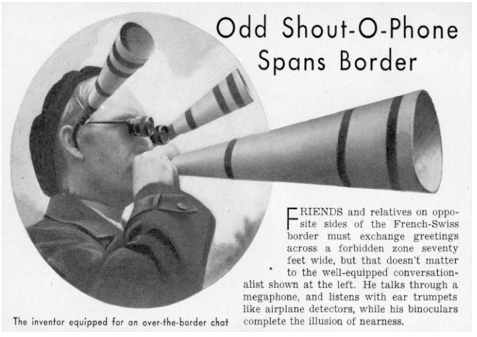

1. Why is it that you have to be profoundly deaf in both ears to receive a cochlear implant? (2 marks)
2. Identify the labelled parts of the diagram and explain their function. (5 marks)

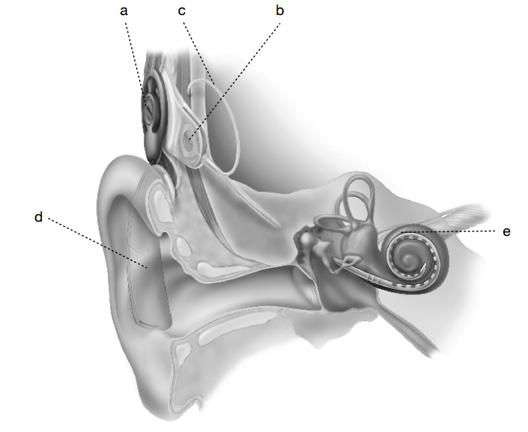

1. The fitting of a cochlear implant can make a huge difference to the quality of life of the recipient. List 2 disadvantages and 2 advantages the recipient would gain after the fitting of the cochlear implant. (4 marks)

